1.a)Genus is the parent class while Species is the child

b) because of composition

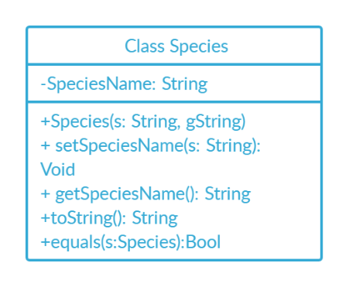c)

d) - Genus is the parent of specimen and spicies, the coding team can benefit because of the reusability of the code.

- Secondly the team progammer don’t need to rewrite code form genus to specimen or spicies.

e)i. because toString already been overided in Genus

ii. same overriding

2.a) Wrapping a data in a singel unit, think of it as a pill. Pill hold lot’s of component and hold the component form being taken by outside things, or even spill out.

b) – The code inside the encapsulation can be easily change with new requierment

– Prevent form other code to access private stuff

c) getCage()

d) cageNumber

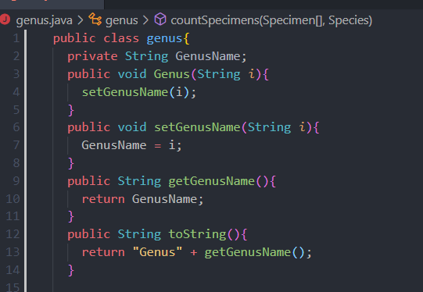e)

3.a)Make a private instance variable because it will be needed in the specimen class,Then add a specify marking in the specimen, then add getter & setter. Lastly add the toString Methods to count for the new variable.

b)

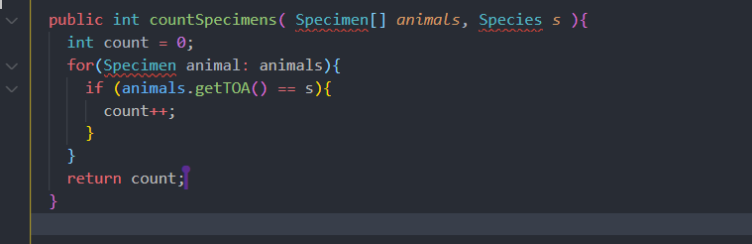

c) pseudocode:

4.a)

-To exports a type

-To exports a set of operations. This set is called interface.

-To Operations of the interface are the one and only access mechanism to the type's data structure.

b)

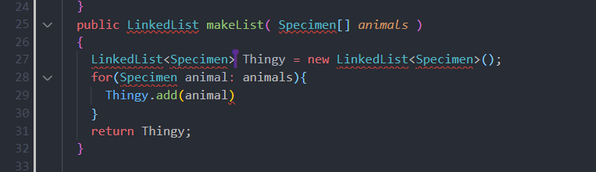

4.c)

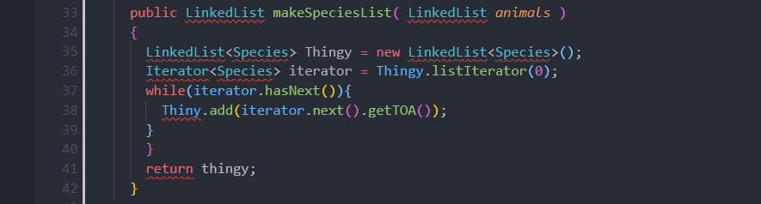

4.d)

